NAME :M.NAVEEN KUMAR REDDY

REG.NO : 192111719

COURSE :COMPUTER NETWORK

CODE :CSA0719

FACUTY :DR.ANITHA.G

LAB 6 TO 10

6.Static Routing using Packet Tracer

**STATIC:**

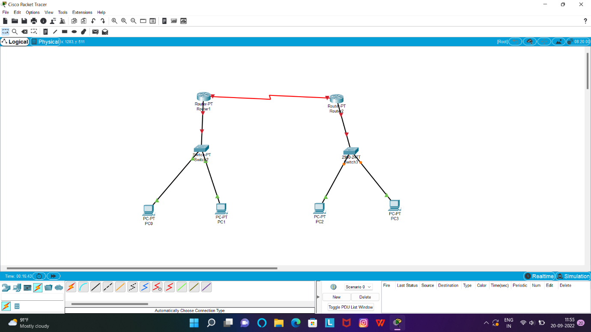

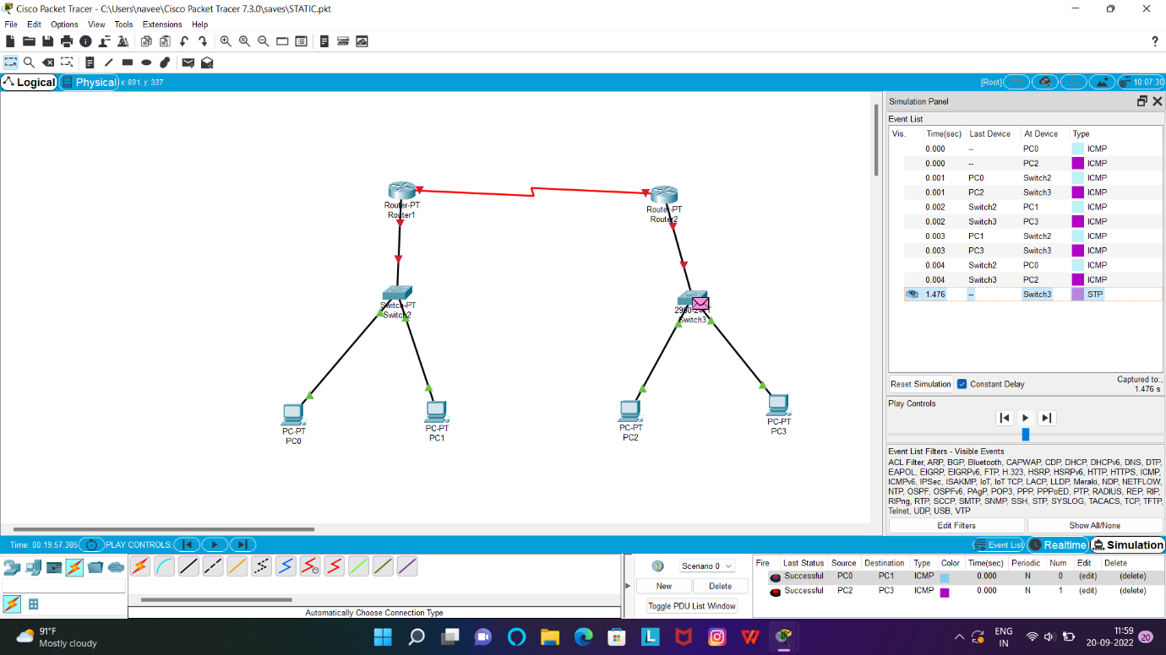

7.Dynamic Routing using Packet Tracer ( OSPF)

**DYNAMIC:**

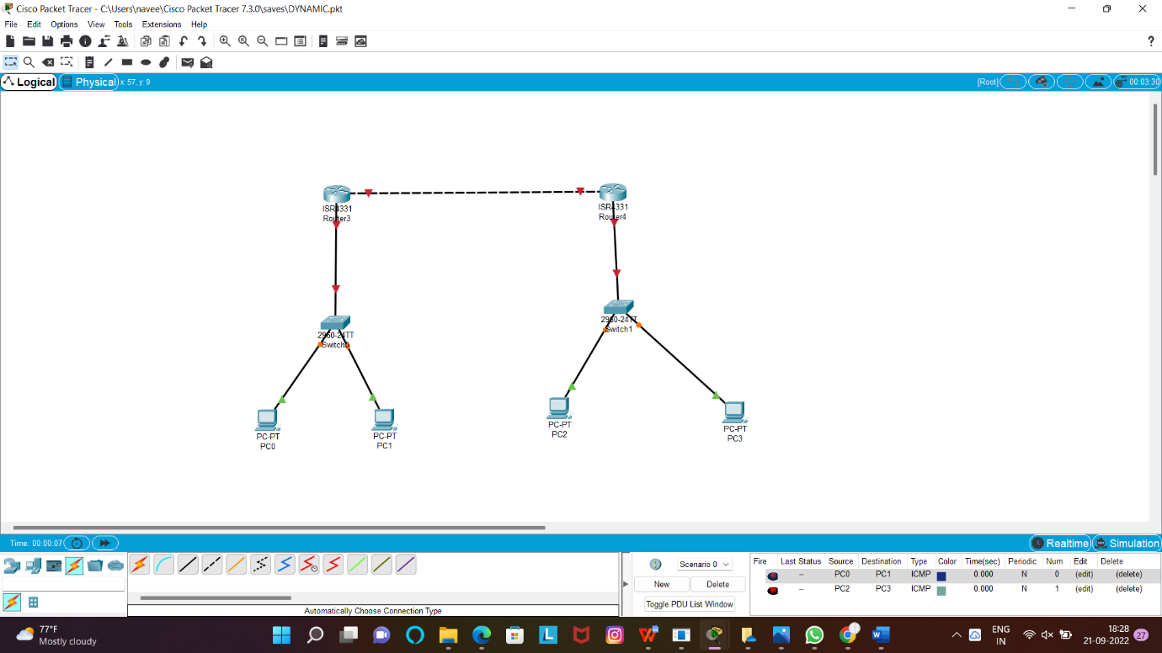

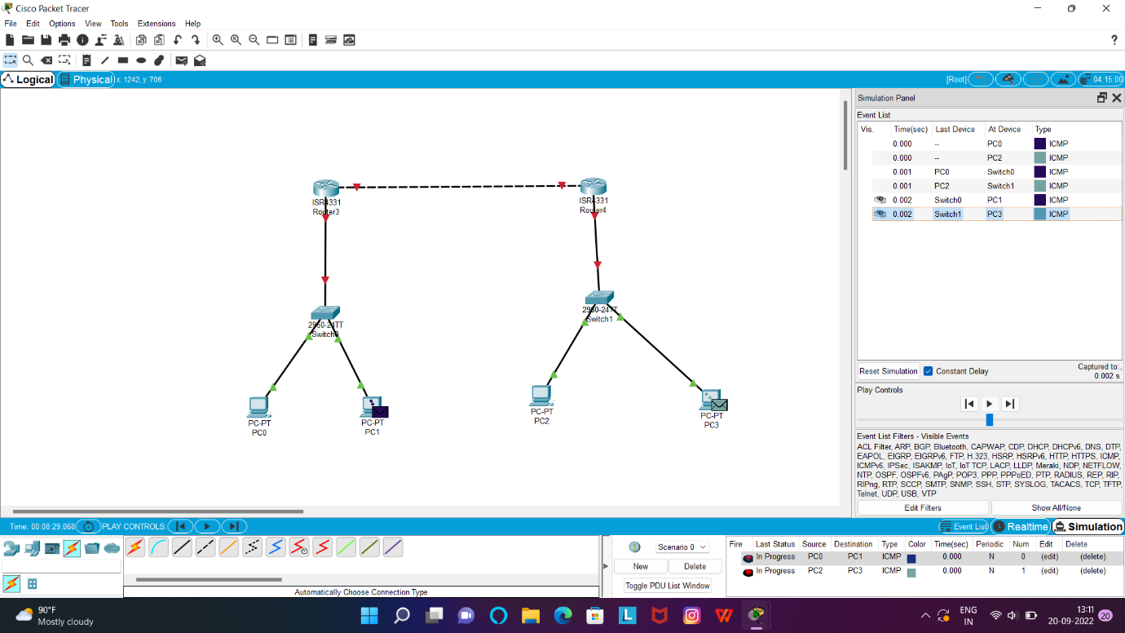

8.Subnetting – Class C Addressing

**SUB NET CLASS C:**

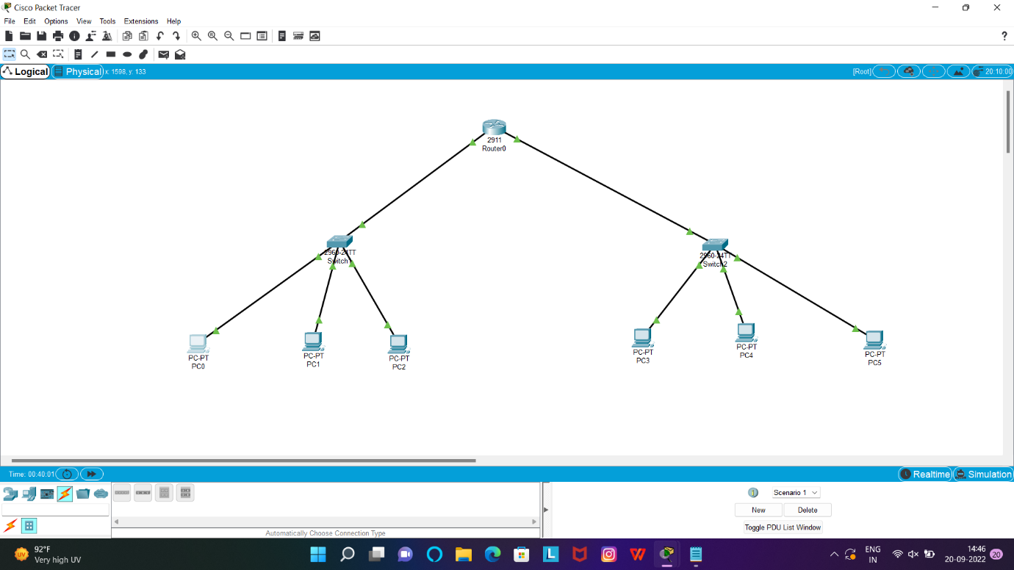

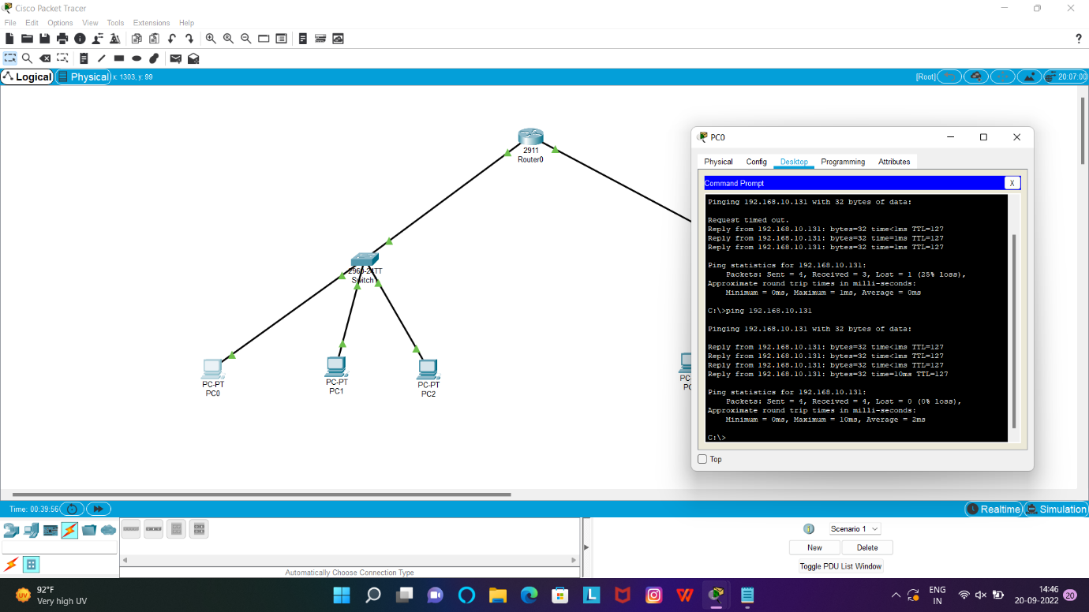

9.Functionalities of TCP, UDP

**TCP,UDP:**

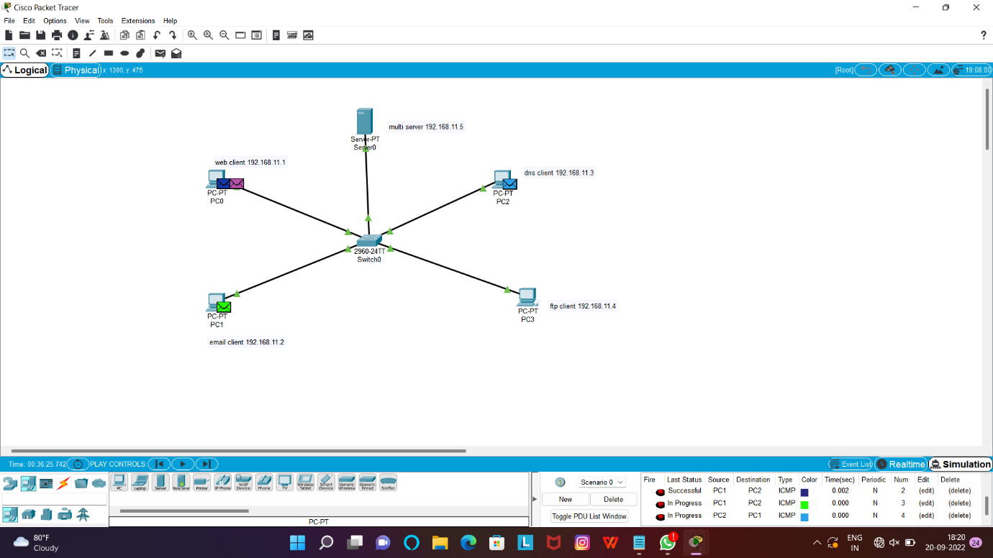

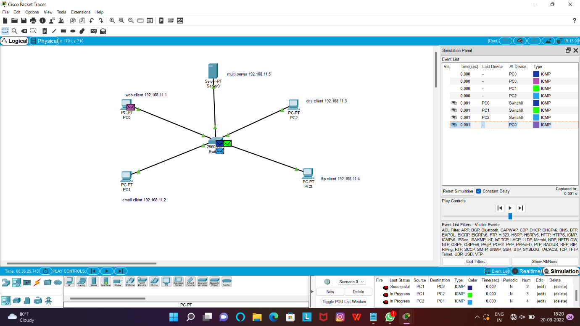

10.TCP, UDP Exploration Solution

**TCP,UDP:**

